Dynapac Equipment Sales Flow

Contents
Overview 2
Work Flow 2
Logging Sales Visit-Mobile Flow 3
Meeting Report &Enquiry Generation 7
Sales Manager Web Login(Enquiry Qualification) 12
Enquiry Progress update via app & Sale Coordinator Web Login 13
Enquiry Status Change by Sales Coordinator 17
Capturing Order Lost 24
Direct Enquiry Logging By Sales Engineer 26
Enquiry Follow up Visit creation 30

Overview:

This document explains about various flow of activities carried out by Dealer sales team in Dynapac Equipment Sales and how they update activities, status tracked by different stake holders.

Work Flow for Equipment Sales:

Sales visit logging to PO Received (For New Customers)
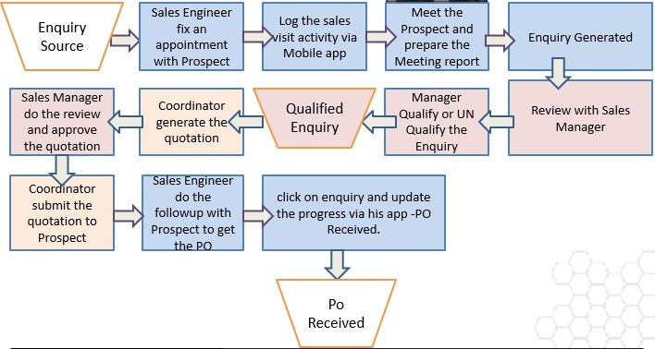

Direct Enquiry logging to PO Received (For Existing Customers)

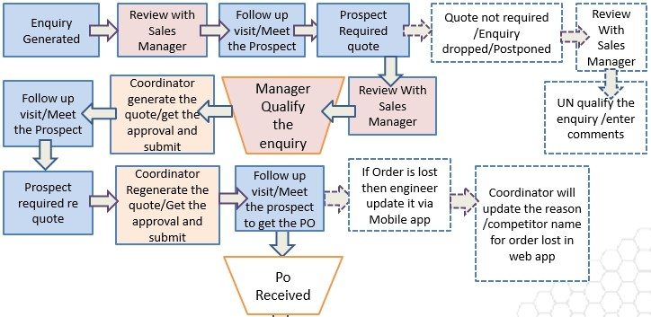
Creation of Visit by Sales/Service Engineer from Mservice app & Auto generation of Enquiry:

Any Mobile user can download Mservice app from Google Play Store or App store (iOS). After installation of the app, the user needs to share the device id (visible to the bottom of app screen) to OEM Coordinator to enable the access and this device id is unique for individual users. Once access is given fill the details like: Client ID, Country Code, Username and Password and click on register for registration of the app as visible in the below image.

For example:

Username: dlrsa1
Password: *******

Note: For testing purpose choose the Environment by clicking 5 times on Mservice Logo and Select “Customer UAT” option and then enter the login credentials as in below screen. All entries should be in small case letters without any spaces

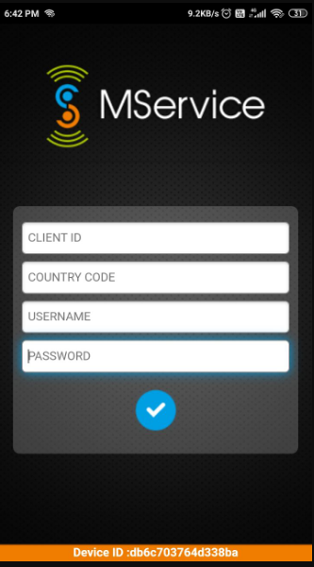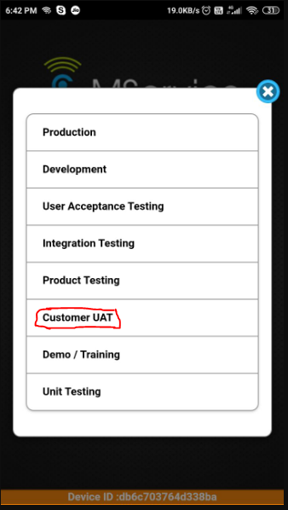

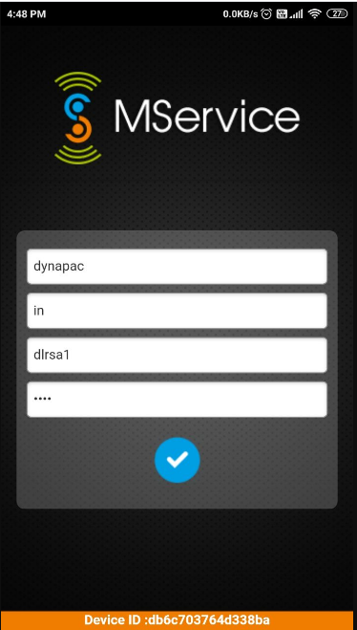

After registration, the Sales engineer can log a Prospect Visit for a new customer from Sales Visit Logging or can generate an enquiry directly from Enquiry Logging options available on home screen.

The flow is similar for both Dealer Sales engineer & Dealer Service Engineer for Sales visit Logging & Enquiry generation from Mservice app

Simultaneously, any Sales visit or Equipment enquiry logged from Dealer service coordinator or Dealer sales coordinator web login also can also be viewed & processed further from a particular Dealer engineer’s login, if it is assigned to that particular engineer.

When clicked on Sales visit logging option ,it asks to select the Prospect Visit Type from the list of options available as drop down as shown in below screen ,& need to click on Tick button to continue filling visit details

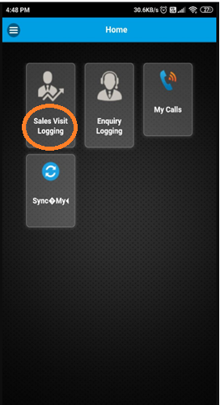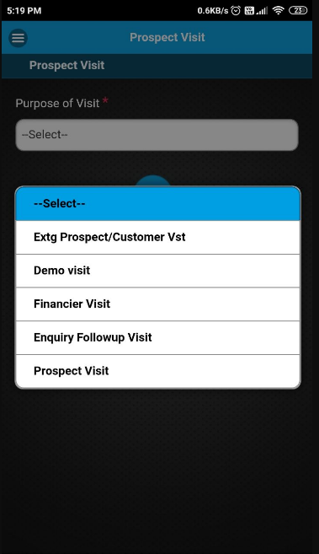

Sales engineer needs to fill up the mandatory fields marked with (*).After filling up all necessary information. Then the sales engineer needs to click on Tick button at end of page & should click on OK to confirm.

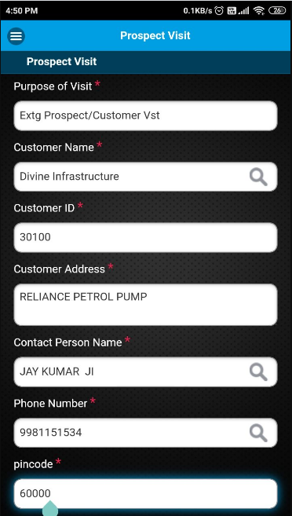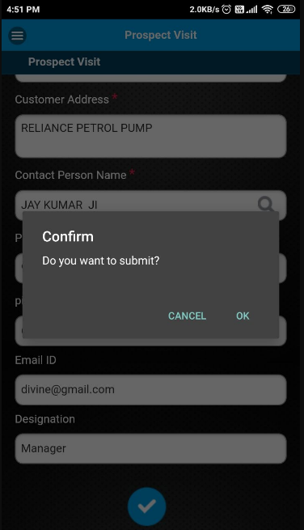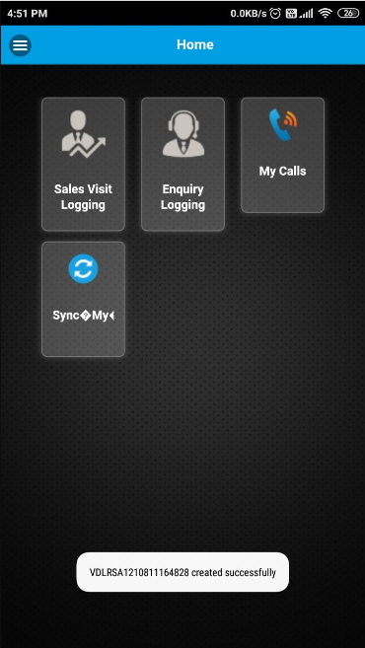

After confirming the submitted details, a Visit number will be generated .The Visit number will start with a prefix V.
Simultaneously, the system will add this customer info in the database with a unique customer id & that customer id can
be used for Direct Enquiry logging either from Sales /Service engineer’s mobile app or from Sales /Service Coordinator’s
WEB application.

The newly created Visit number will appear under “My Calls”. Sales/SE Engineer need to click on Sync My Calls to refresh
the calls. The new visit generated will be appearing in “Assigned status”.
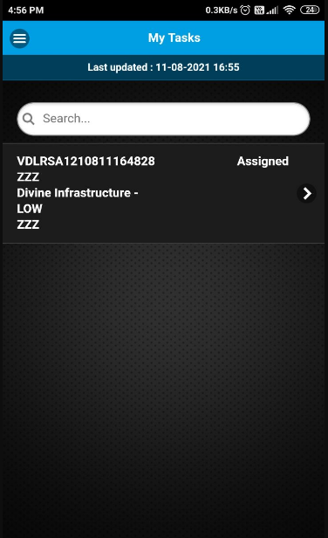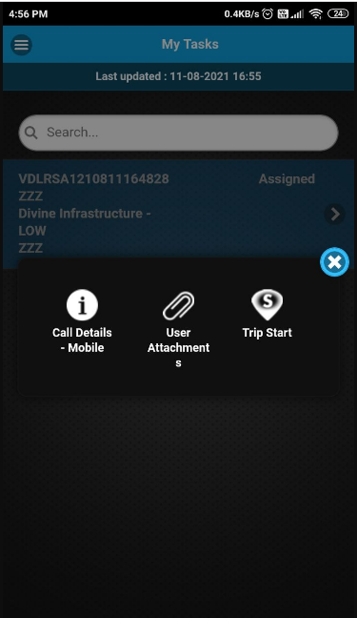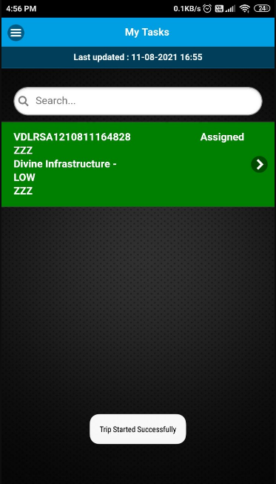

Once the Visit number gets visible in My Calls, the Sales engineers can do Trip Start by clicking on the visit number when
he starts his journey to the customer location. Trip started successfully msg flashes at bottom of screen. Once the Trip
start is done the Visit color Automatically changes to “Green” indicating that it is the “ACTIVE CALL” and it appears at the
top of other calls.

When the Sales engineer reaches the site/Customer location, He can click on the “Trip Finish” option. A msg flashes at the
bottom of the screen as “Trip finish successfully”. Engineer can do Trip Start/Finish multiple times to record their trip
details if there is a break journey.
.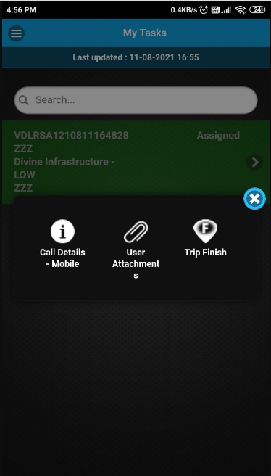 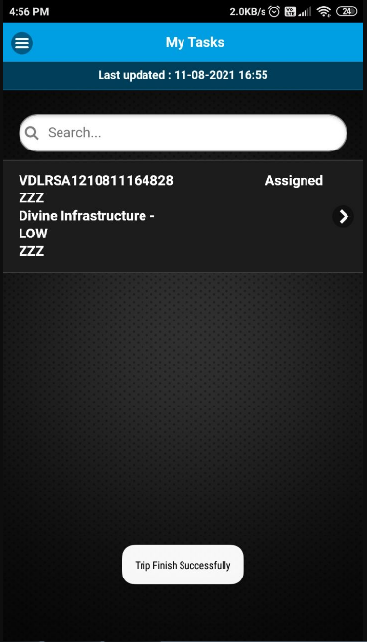

After reaching to the prospect customer, Engineer can do Meeting Start to start the meeting .Meeting date & Time are
Automatically displayed on screen. On clicking tick, “Meeting start successfully done “msg flashes at the bottom of the screen

Once the engineer does the Meeting Start, the Visit number will again go back in Green color & the app will not allow the sales engineer to proceed for another visit. The status of the visit will also change to “In Progress” now

During the meeting, the sales engineer can note down the customer’s requirements in Meeting Report by clicking on that visit.
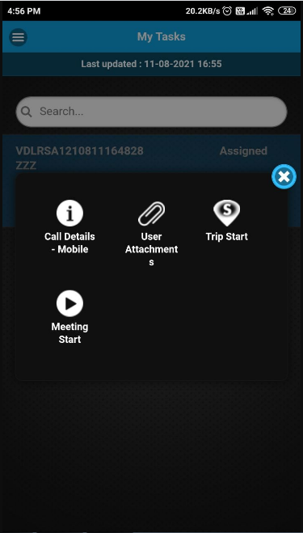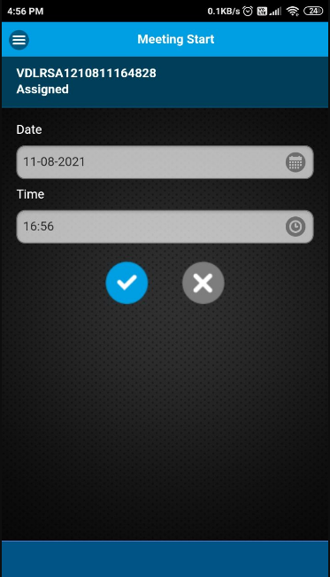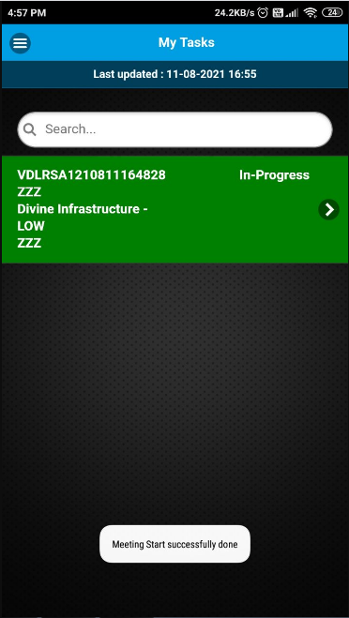

The Sales engineers need to fill up all the required information marked with (*) & also record their location by clicking on
Tag My Meeting Location. After clicking on Tag Location, the app will fetch location from the Google Map. The arrows
Located in the middle will help engineers to surf through the Previous & Next pages. And the outer arrows will help
Engineers to directly go the first & last pages.

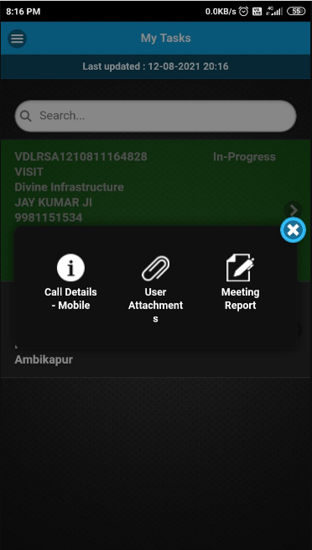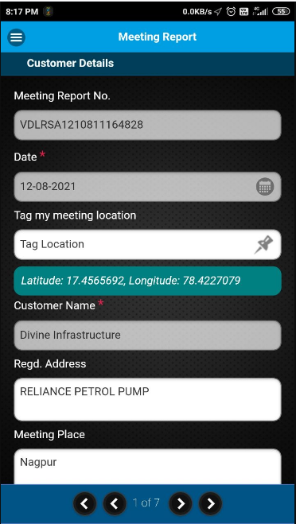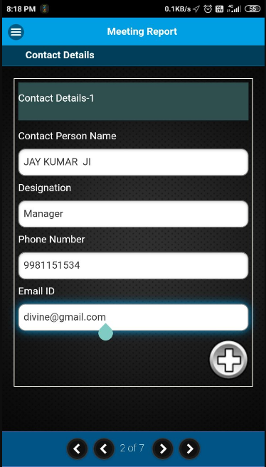

If there are multiple contact persons then sales engineers can generate a new field by clicking on (+) button below. In the first page of Meeting report Prospect details should be filled.

In the second page customer contact details are automatically fetched from customer master or can be added by engg.

The engineers can capture the Existing fleet list of the prospect in the 3rd page .The sales engineers need to select the Equipment Category from the drop down. If the customer has some existing fleets ,that can be added one by one.
Plus(+) button allows to enter additional entries.
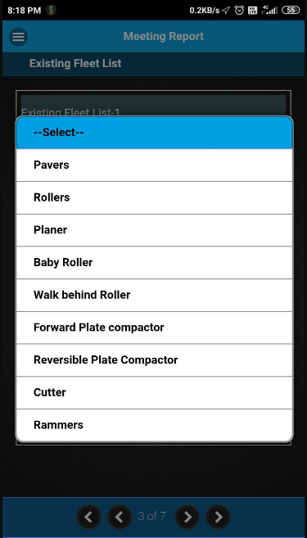

There is a delete option if there is some mistake happened while entering existing fleet details. The sales engineer need to
Select the Customer Type & Customer Segment from drop down in the 4th page. Multiple segments selection also can be done
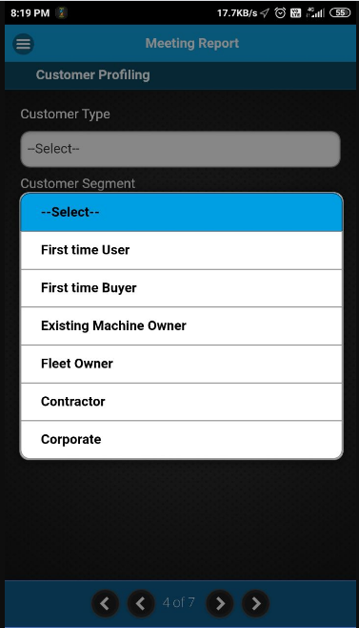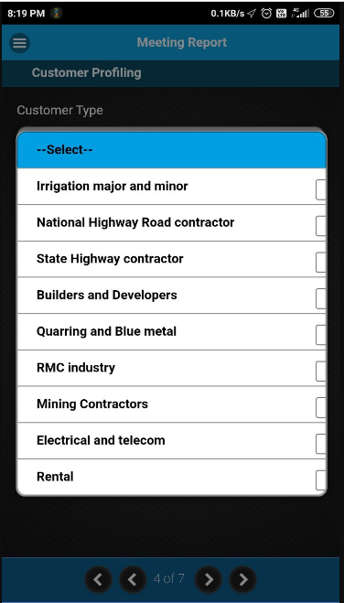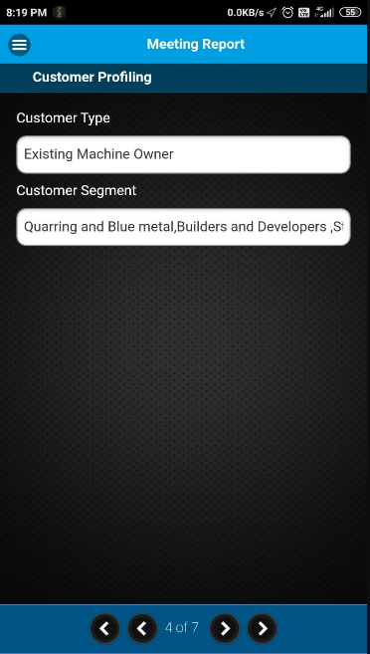

The Sales Engineer needs to collect the Financier Details from the drop down in the 5th page. There is a flip switch given to choose Own Source; Letter of Credit (LC) ; Bank Guarantee (BG) details.

Sales/SE can capture the Customer’s New Equipment Requirement details in the 6th page of form

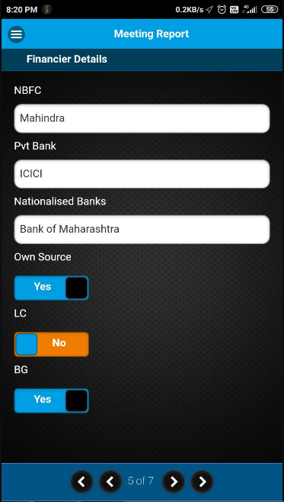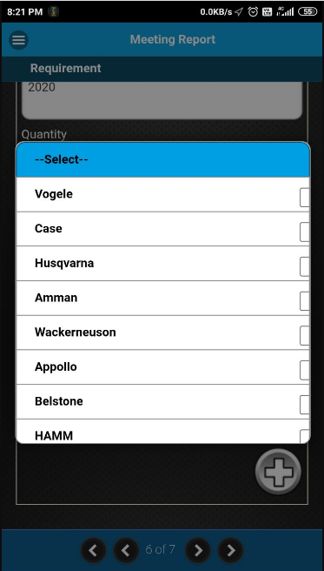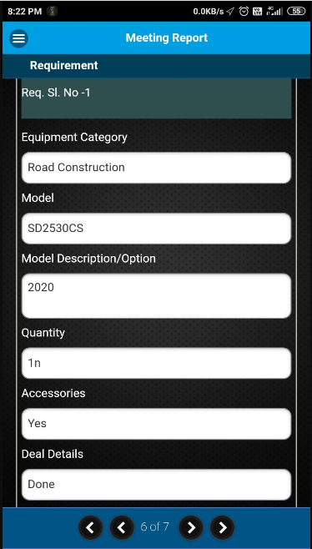

Then the sales engineer needs to enter the Next Follow-up date & a Probable date of closure of the deal. By clicking on
The “EYE” button, the sales engineer can verify the information which he/she has entered in the meeting report before
Submission.

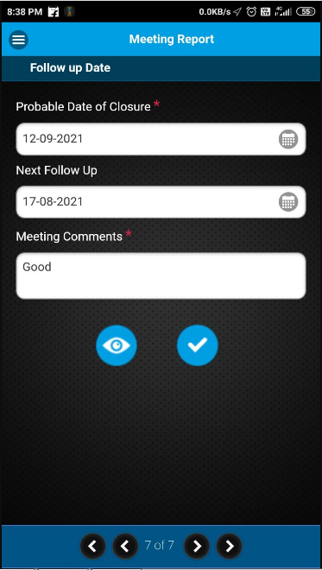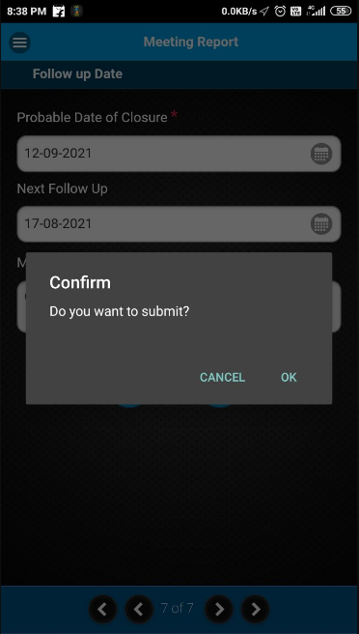

The visit report preview will be shown in .html format & user also can select HTML viewer/ any web browser to view the
same. After verifying all of the information, sales engineers can submit the visit report by clicking on Submit button. And
by clicking on OK, the visit report will get submitted.

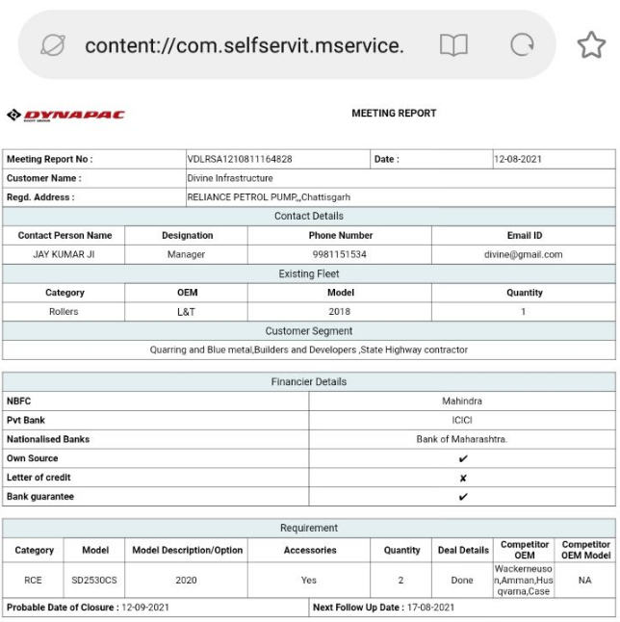

Once the meeting report is submitted, the Visit status will automatically change to “Complete” as in below image.
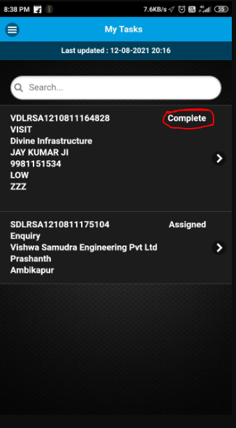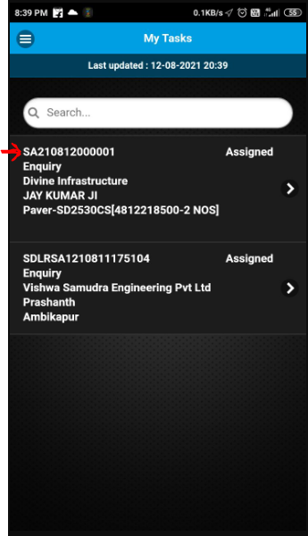

Now in WEB login, the Sales Manager or the Dealer coordinators can Qualify/Unqualify the enquiry Auto-generated based on the Sales Visit’s Meeting report.

Sales Coordinator/Managers can do web login via their credentials.

The site URL is: http://dynapac.mservice.in/

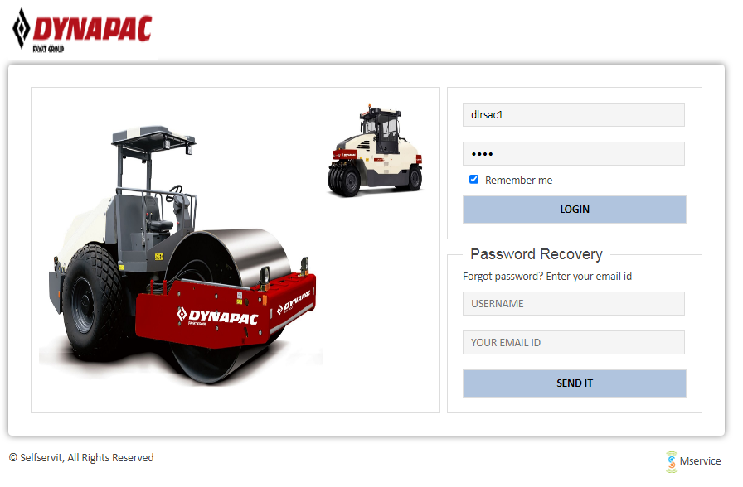

The Sales Manager/Sales coordinator needs to click on the Enquiry Management under Equipment menu.

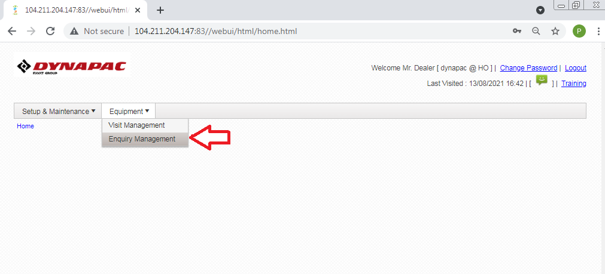

The new Enquiries will be shown in Assigned status starting with SA. The Sales Managers can view the enquiry & click on
The Qualify button under Action menu in order to Qualify it.

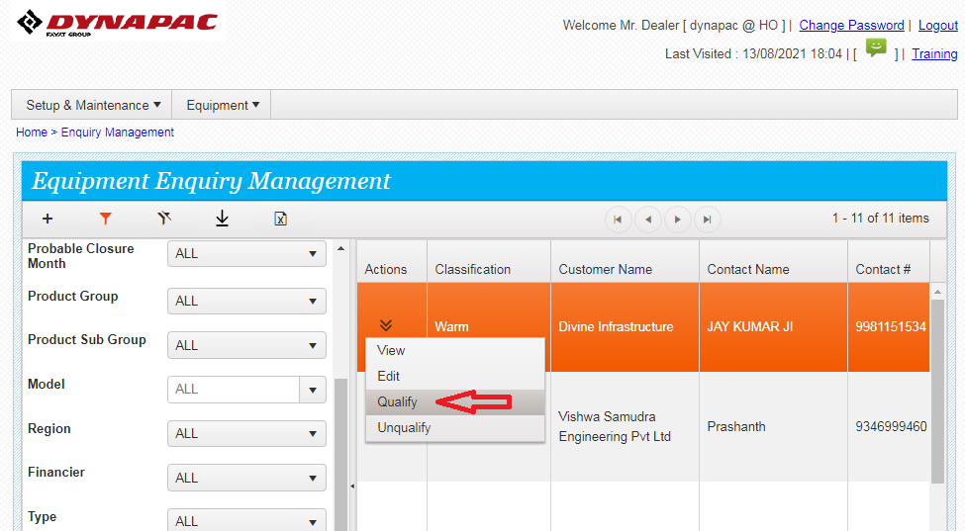

Sales Manager can enter comments if any in the dialogue box & submit. Then needs to click on OK, when popup
Shows “Qualify successfully done” as in below screen

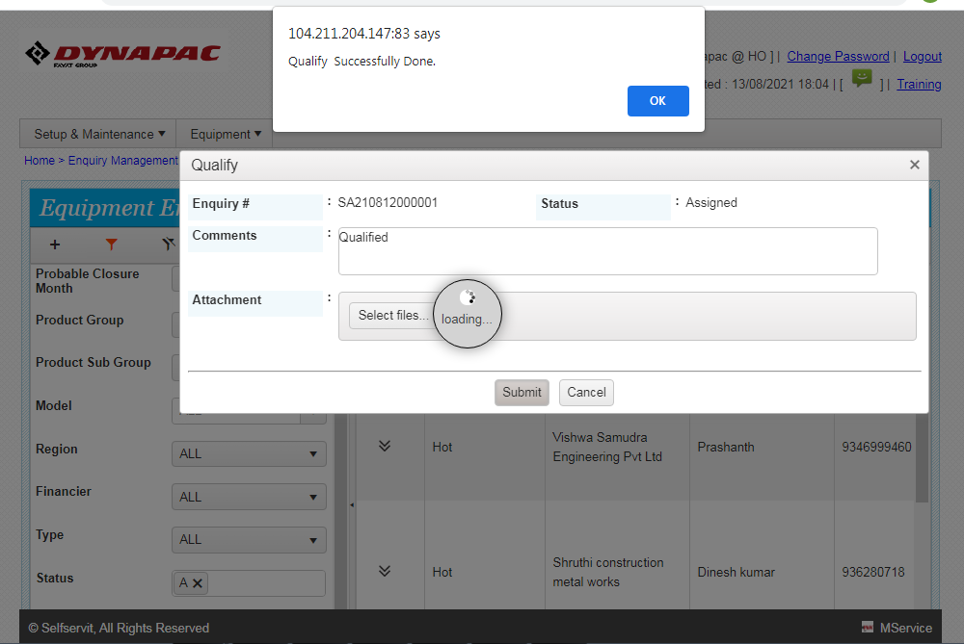

Then the qualified entries will be updated in the sales engineer’s mobile app under My Calls. The enquiry status is now
Changed from Assigned to Qualified as seen in the below image.
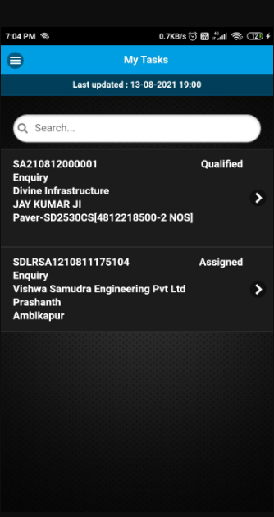

By clicking on Progress Update, the sales engineer can update his activities (Such as Quote submit, Advance received, FI
Done, Financier Case In, PI Given, DO Received, Order Lost) done for the enquiry & also can up upload the picture from
Attachment option if any document available for that action. Any comment can be given the same time.

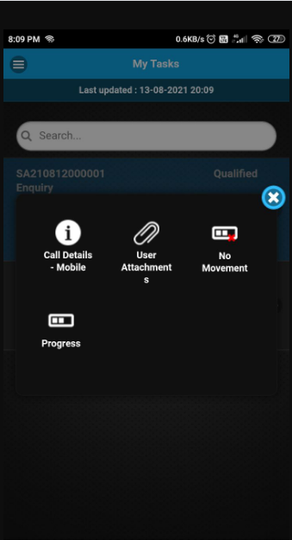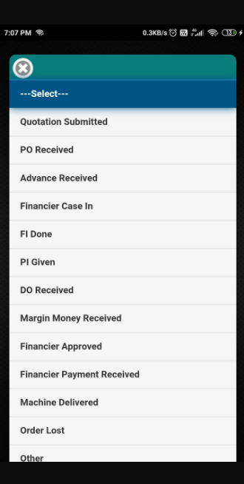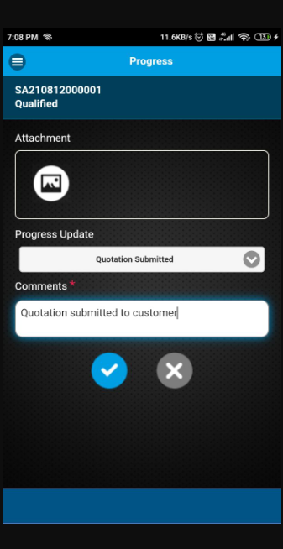

The Progress updates done by Sales Engineer can be viewed by Sales coordinator in Equipment Enquiry details under logs

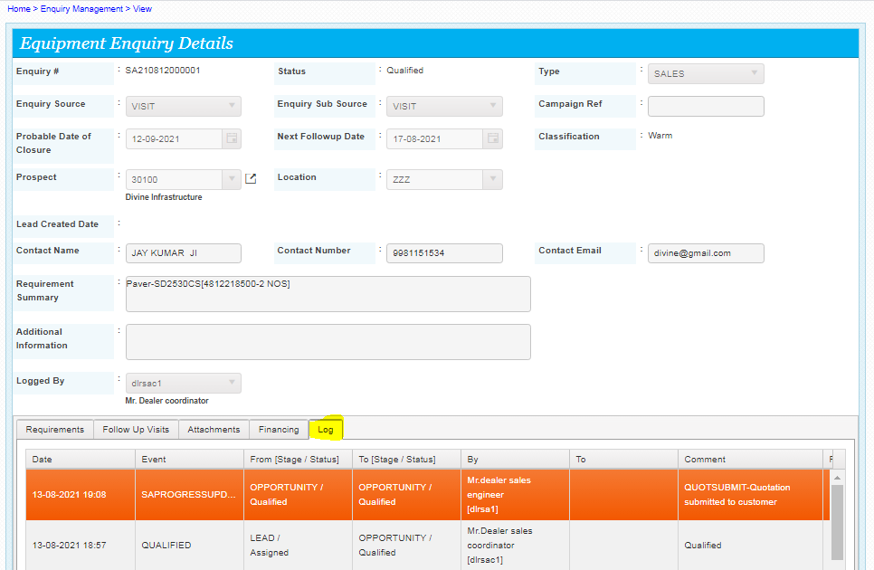

The Sales Coordinator can check the engineer’s activities & comments from his/her WEB login under enquiry Logs & can update the enquiry status further.

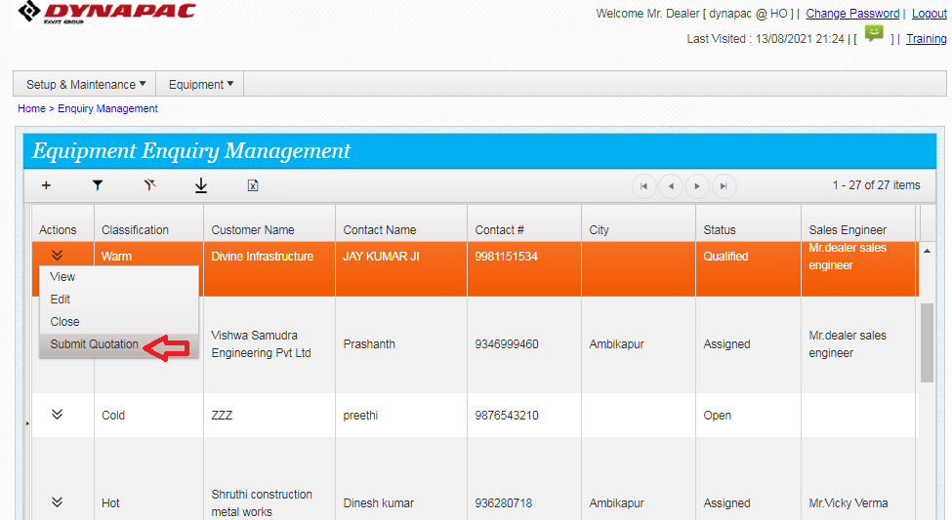

After the logging, the sales coordinator will view the comments given in the enquiry by the sales Engineer & update the
Relevant status from the action button. By this way, the sales coordinator can change the enquiry status till Billing Done &
Each status update by the sales coordinator will be visible in sales engineer’s mobile app as well.

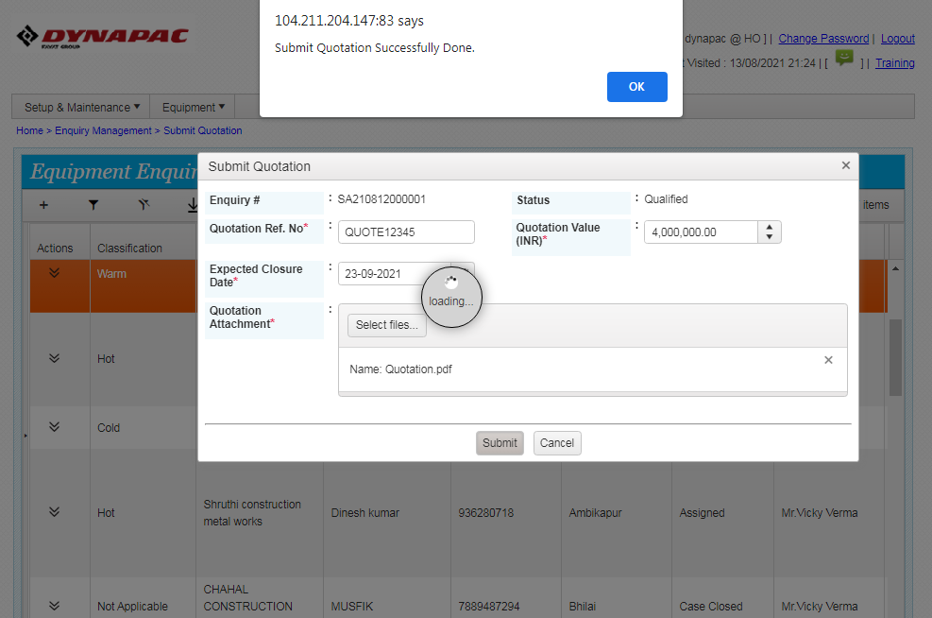

As shown in the above images, the Sales Coordinator has changed the Enquiry status from Qualified to Quotation
Submitted after information received from sales engineer’s comments. And the same status change is reflecting in Sales
Engineer’s mobile app as well in below screen.
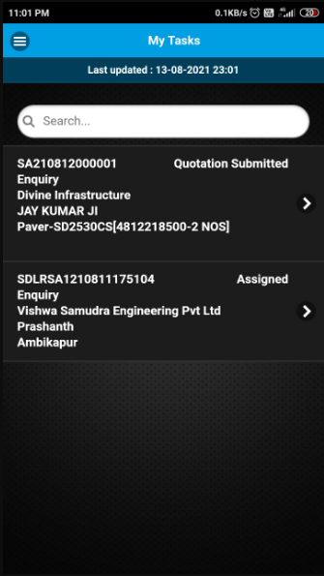

The Sales Engineer can also update the status as No Movement if there is no progress made for the enquiry for the day.

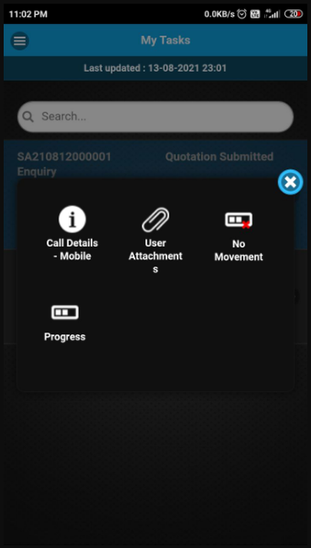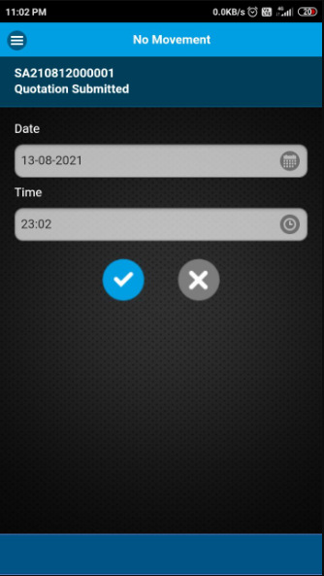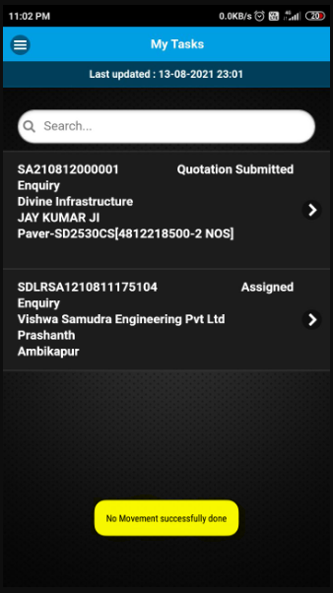

In case of Order Lost informed by the Sales Engineer, the Sales Coordinator has to mention the Lost Quantity,
Reason, Competitor Name, Competitor OEM Model & comments if any in the Order Lost screen in the web.

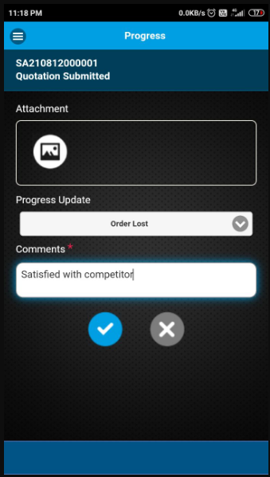
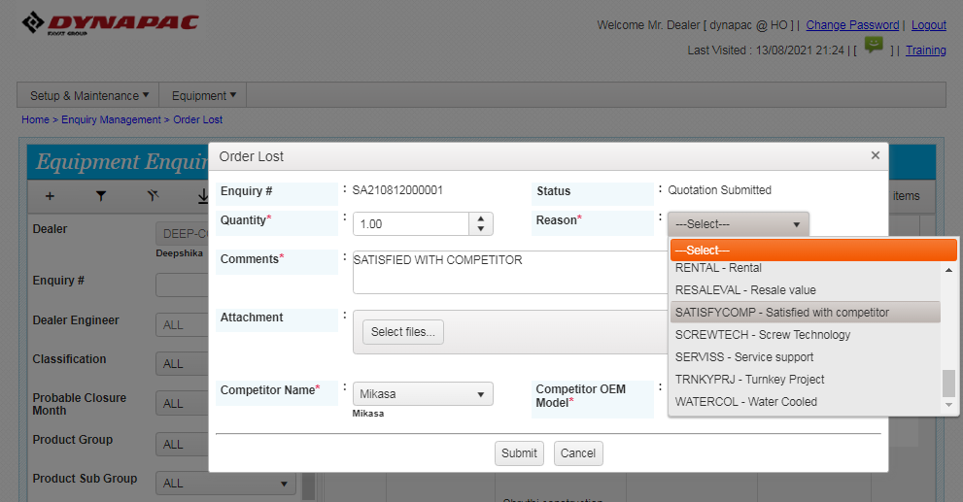

After the Billing Done/Order Lost, the completed enquiry cannot be seen in My Calls of Sales Engineer’s
Mobile app.

Please Note: Order Lost option will be available before DO Received in Sales Coordinator login. (Please see
The app flow given in page no.02 for reference)

Direct Enquiry Logging By Sales Engineer from MService app:

The Sales/SE Engineer can directly log an enquiry from Enquiry Logging option given in the mobile app for an Existing
Customer

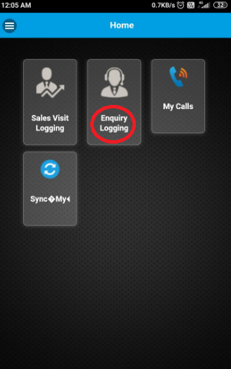

The sales engineer has to fill up an Enquiry Logging form similar to the Meeting Report. After tagging the location in the
1st page of that form, engineer has to search & select the customer. Engineer can search the customer by typing the
Customer name or the customer id in the Prospect Name field & relevant customer names will appear in drop down. Then
The engineer needs to select the customer name from the drop down.

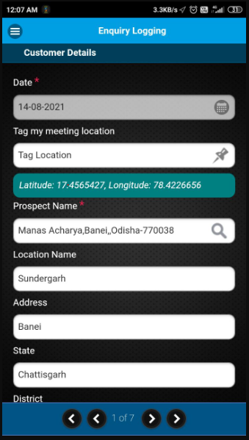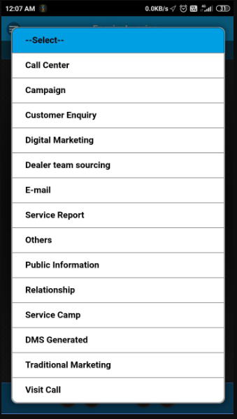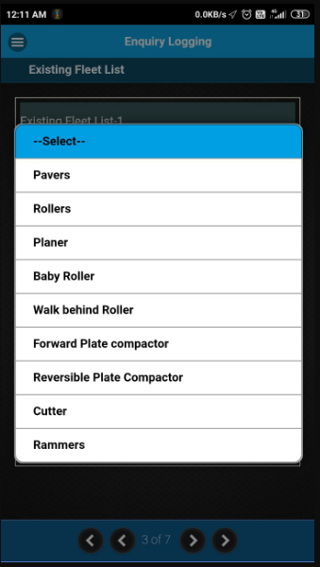

Also the sales engineer has to mention the Enquiry Source & Enquiry Sub-Source from the drop down in the 1st page.
From the 2nd page, the sales engineer has to fill up the requirement details similar to the Meeting Report.

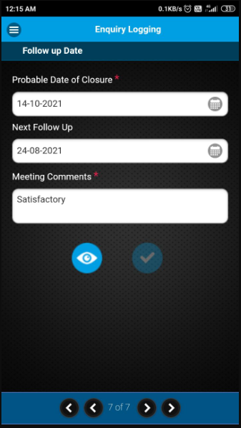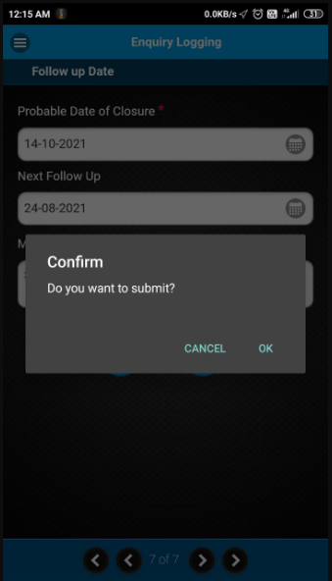

After confirming the details & clicking on OK, the preview of the Enquiry form filled will be shown in .html format &
User also can select HTML viewer/ any web browser to view the same.
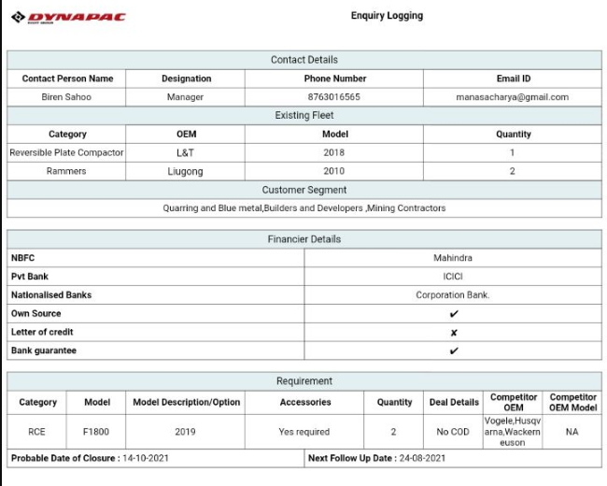

After submission of enquiry details, an Enquiry number will get generated & auto-assigned to the Sales Engineer. The
Newly generated enquiry can be found under My Calls starting with prefix S.

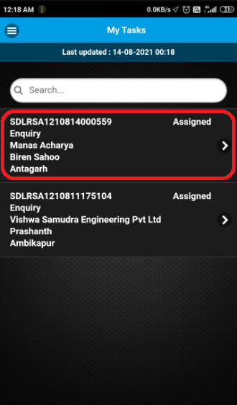

Enquiry can be processed further in app by sales Engineer, after getting qualified by the Dealer sales manager/sales
Coordinator.

The sales engineer can update his activities from Progress Update option or No Movement option in app & the sales
Coordinator can change the enquiry status till Billing done or can do Order Lost from his login.

For Any open Enquiry, Sales Engineer can create a Follow up visit, Demo visit or Financier visits also, if he is visiting
The customer for further progress on that enquiry.

For a Demo Visit & a Financier visit, meeting report is not available. These Visits has only Trip Start---Trip finish---
Meeting Start ----Meeting finish options

To search for Existing Enquiry of a customer, customer name should be typed & click on search, automatically existing
Enquiry Number of that customer will be available in dropdown

Enquiry Follow up Visit Flow:

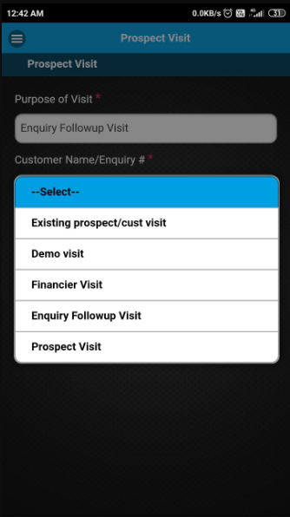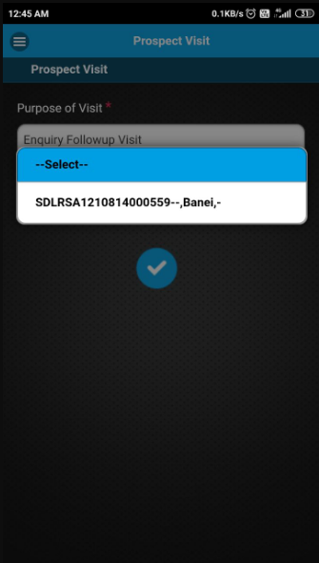

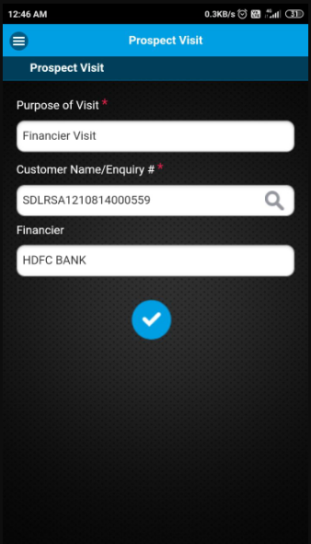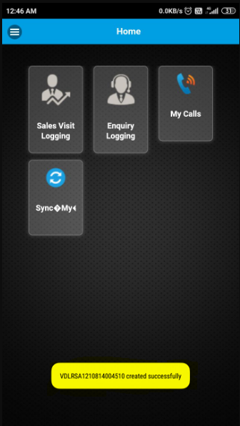

On successful creation of a follow up visit , flash msg will come at the bottom of the screen as in above image.

Any Follow up visit created for Existing Enquiries will also be available under My Calls.

And the Meeting report filled for such follow up visits will be available in Sales coordinator login under both Visit call
& Enquiry calls.

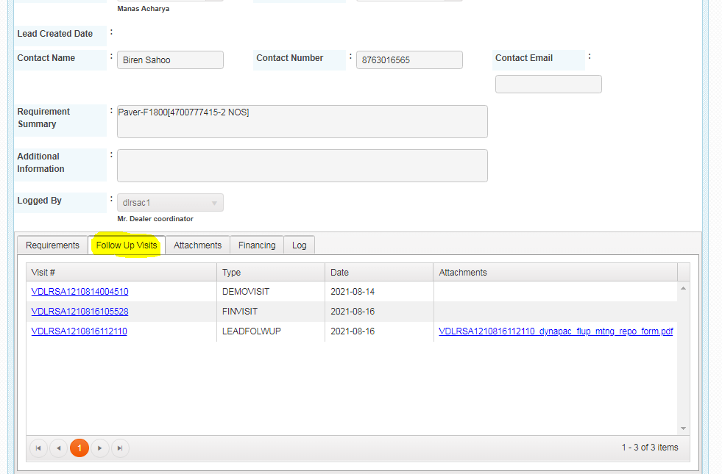

All the multiple Follow up visit details, done for an Enquiry are simultaneously available under Equipment enquiry details as in Above screen shot along with Attachments.

